FINANCIAL LITERACY
SOURCE DOCUMENTS
PART 1
When you go to the shop and buy a cool drink what does the teller do you? The teller rings the amount on the till (cash register), the amount of money you gave and the till will show what the change will be.
For example: a 2L coke costs R22. You give the teller R30, a R20 and R10 not. You will be given change of R8. All of this is recorded on the till slip which you will be given.
But why must you be given the till slip?
This is your proof that you have paid for the coke. If the security guard came up to you, he would want to see the till slip as proof that you did pay for the bottle of coke.
What you may not be aware of is that the shop also keeps a copy of the till slip. Why do you think they also need to keep a copy?
____________________________________________________________________________________________________________________________________________________________________________________________________________________________________________________________________________________________________________________________________________________________
Business transactions take place on a day to day basis, example: stock is bought, wages are paid, bank deposits are made, other expenses are paid, etc. Every business activity or transaction is recorded on some form of documentation. This serves as proof that the transaction has taken place. The proof is important in the event of a disagreement with a customer, a supplier or the bank. Therefore it is important that the documents are properly completed and copies of these are filed for future reference. These documents will also be used in the recordingprocess which will be discussed later.
This then becomes known as the source document for that particular transaction. These documents become very important in the recording part of Accounting.

RECEIPT
If you pay your school fees, swimming lessons or any other payment made, you probably be given a receipt as proof of payment.
An example follows:
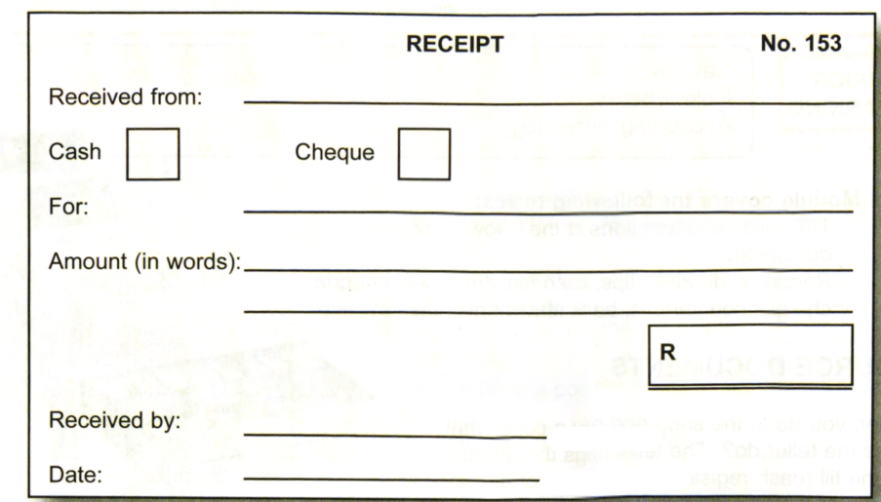
- The design of the receipt may take different forms.
- General receipt books for use by any business can be bought from stationery shops, or the business can have personalised receipt books, which are specially printed for them and will have the business name and logo on it.
- A receipt is printed in duplicate (2 copies). The customer usually gets the original and the business keeps the copy.
- The main details included on a receipt are as follows:
- Name of the person who made the payment
- The amount paid in words and figures
- The date
- The signature of the person who received the money
- The reason for receiving the money

ACTIVITY ONE:
You are giving swimming lessons to girls and boys between ages of 3 and 6. Mr Jones gives you a cheque on 5 March 2020 for R240 to pay for Pauls lessons for the month of March 2020.
REQUIRED
Complete the receipt below and then answer the questions that follow:
RECEIPT  Received from: | N | o. 153
Cheque
Cash

For:
Amount (in words):
Received by:
Date:
 | R

  - Why is it necessary to write down Mr Jones’s name?
  - Why does the receipt have to be dated?
  - Why must the amount be written on the receipt?
  - Why must the receipt be signed?

CASH REGISTER TAPE /TILL SLIP
- A till slip is produced when goods are bought, or a service given, and the customer pays cash.
- In this case the teller does not write your name down. This is because you have paid for the item and you do not owe the shop any money.
- The customer gets one copy of the till slip and the duplicate is kept in the till for the business’s use.

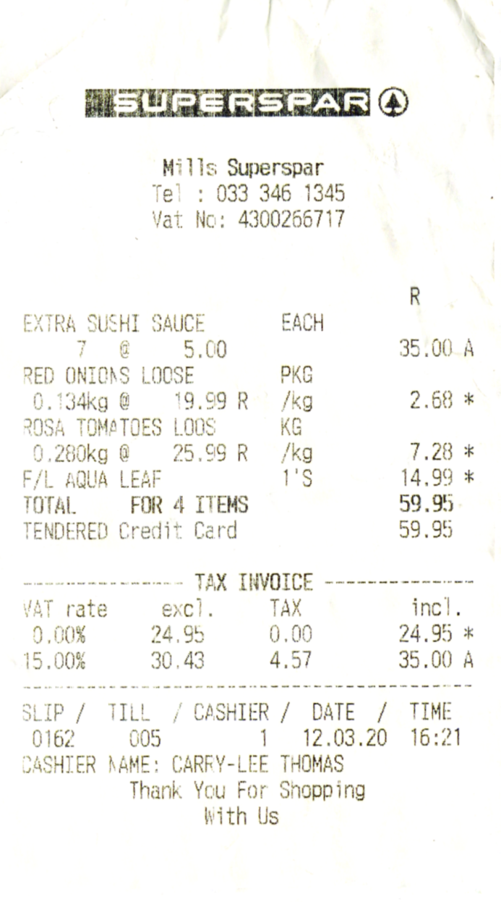

CASH INVOICE
- Some businesses do not have a cash register to record their cash sales so will issue a cash invoice.
- A cash invoice is very similar to a receipt although it will give details of items bought and paid for.
- Cash slips take many forms
- Books of cash slips can be bought from stationery shops.
- Business may have their names on cash slips pre-printed.
- The may also have specially programmed cash registers to print individual slips when their customers purchase goods for cash.
- It should be noted that cash slips are numbered so that the owner of the business can account for every sale and ensure that the cash received for the sale of goods is banked.
- Cash slips are prepared in duplicate.
- The customer will keep one copy as proof of transaction.
- The business will keep one copy for internal control purposes and for the purpose of writing up the books.
Example of a Cash Slips
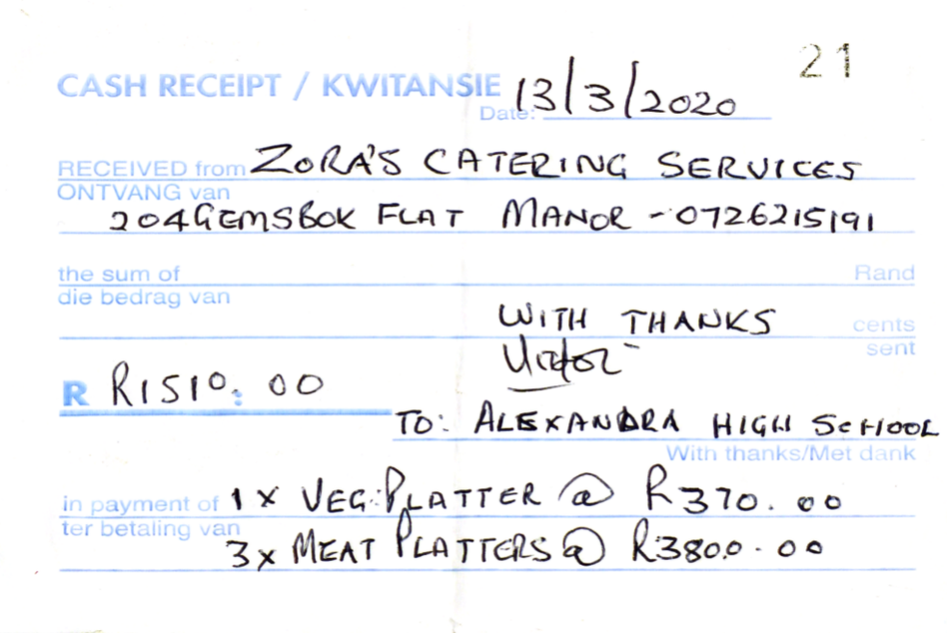
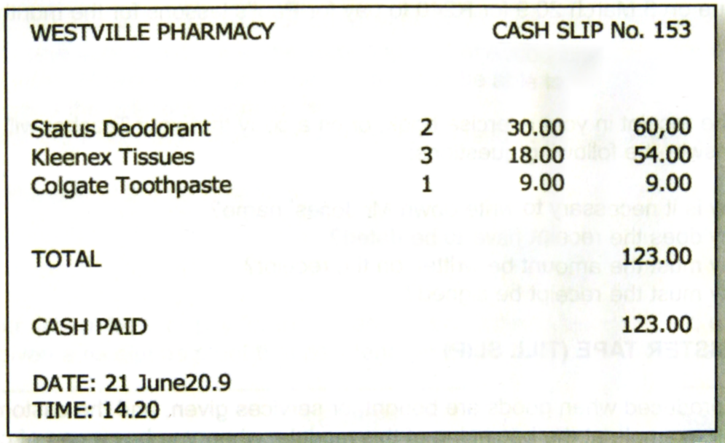

DEPOSIT SLIPS
- In all cases of financial transactions with a bank, it is important to keep proper documentation as proof of the transaction which has occurred.
- The document that is used when depositing cash into the bank is called a deposit slip.
- These are provided free of charge by the banks.
Important points concerning deposit slips are:
- The deposit slip is prepared in duplicate. The bank keeps the original. The bank uses this to update the customer’s account. The customer keeps the copy, which must be stamped by the bank to conform that the funds have been deposited. The copy enables the customer to check the bank’s record when he receives a bank statement at the end of the month.
- There is a section on the deposit slip for cash deposited and another section if cheques are being deposited

